**GIT:**

1. Git-HOL:

* Setup your machine with Git Configuration
* Integrate notepad++.exe to Git and make it a default editor
* Add a file to source code repository

OUTPUT:

1. Git-HOL:

Git ignore:

* Implement git ignore command to ignore unwanted files and folders

OUTPUT:

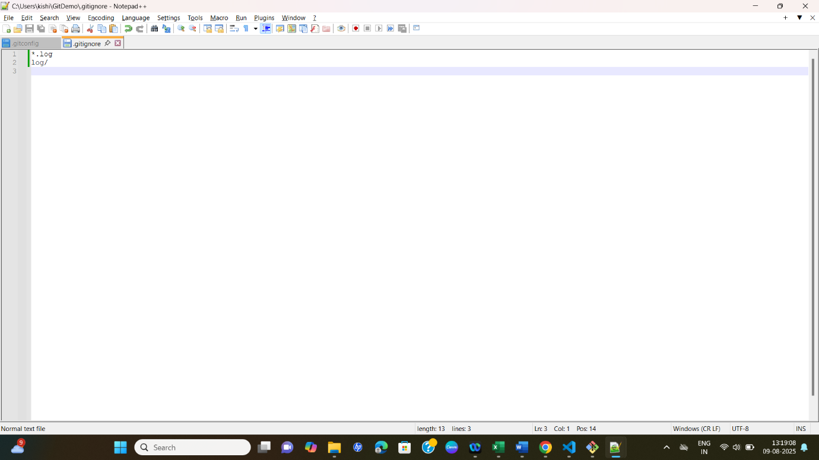

1. Git-HOL:

* Construct a branch, do some changes in the branch, and merge it with master (or trunk)

OUTPUT:

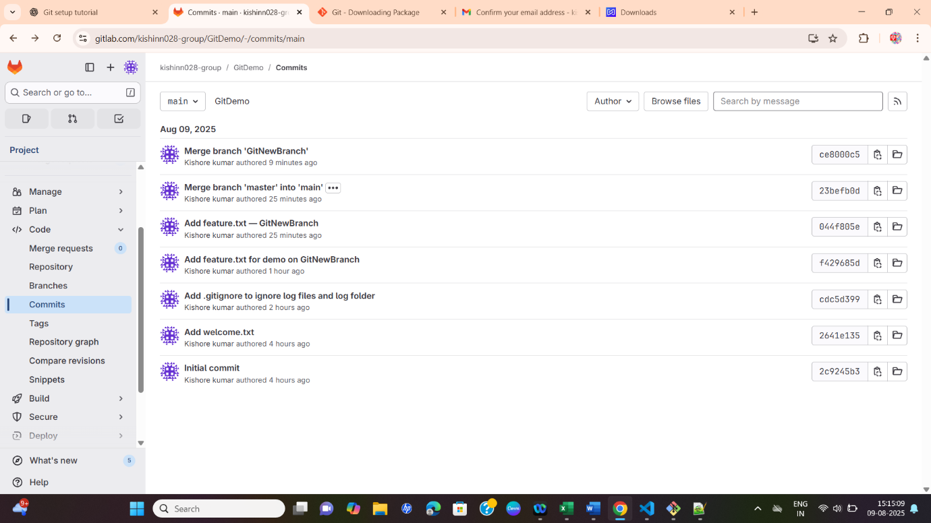

1. Git-HOL:

* Implement conflict resolution when multiple users are updating the trunk (or master) in such a way that it results into a conflict with the branch’s modification.

1. Git-HOL:

* Execute steps involving clean up and push back to remote Git.

OUTPUT:

